Step 3: To size the fabric for your hoop put the fabric between the two hoops and stretch the fabric taut. Tighten the screw. Using your scissors trim close to the outside edge of the hoop as shown in the second picture. Repeat this for the second piece of fabric. You will need one for each side of the hoop.

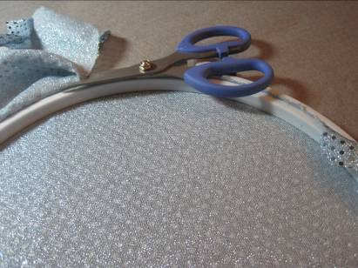
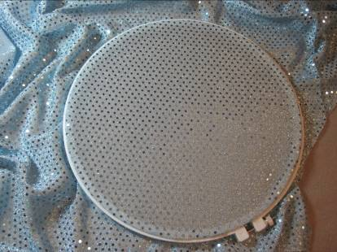

Stretch Fabric on Hoop Cut Fabric Along Edge

Step 4: With the wrong side of the fabric facing you, fold fabric from the top edge about 1/3 the total length and finger crease. Turn fabric over and place ON TOP of the inner ring. You are going to begin gluing your fabric to this ring, using the glue gun. After gluing down the fabric and it is dry and secure, trim excess fabric. Note! Do not apply glue in a thick layer. The glue will get thicker as it cools. You want just enough to hold your fabric. If you glue your fabric clockwise at 12, 3, 6, and 9 o’clock positions it will hold the fabric in place for further gluing without the fabric shifting.

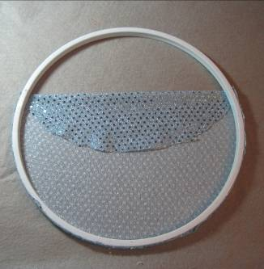
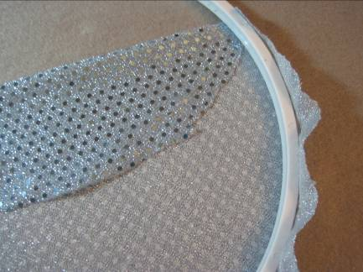
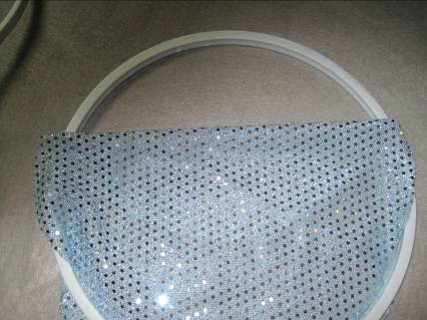

Glue down fabric Fabric not trimmed Fabric all trimmed

